Police Killings in the United State

**Domain:** Crimes, Law enforcement

**Link:** <https://www.kaggle.com/kwullum/fatal-police-shootings-in-the-us/home#PoliceKillingsUS.csv>

This dataset is highly reliable as it’s gotten from the Washington post (a major American daily newspaper). Since Jan. 1, 2015, The Washington Post has been compiling a database of every fatal shooting in the US by a police officer in the line of duty. It's difficult to find reliable data from before this period, as police killings haven't been comprehensively documented, and the statistics on police brutality are much less available. As a result, a vast number of cases go unreported.

The Washington Post is tracking more than a dozen details about each killing - including the race, age and gender of the deceased, whether the person was armed, and whether the victim was experiencing a mental-health crisis. They have gathered this information from law enforcement websites, local new reports, social media, and by monitoring independent databases such as "Killed by police" and "Fatal Encounters". The Post has also conducted additional reporting in many cases.

The Washington post online link: <https://www.washingtonpost.com/>

Source of census data: <https://factfinder.census.gov/faces/nav/jsf/pages/community_facts.xhtml>

**Description of variables**

ID: Unique identifier for the record

**Composite variable generated: By Combining the state and city**

Sign of Mental Illness: Again this is a really sensitive topic. Mental illness such as depression (postpartum depression- which happens to nursing mothers can lead to various unpredictably) and psychotic depression (which I suffer from) can lead to hallucinations and the law enforcement agencies might not know how to adequately deal with such cases due to lack of awareness of the illness. Other mental illness like bi-polar disorder, Alzheimer’s and dementia (which tend to occur more in older people) can also lead to more uncharacteristic behaviors among the victim. Again due to stigmatization, people might not be outright if they suffer from mental illness or not.

There could also be a connection between mental illness and if the victim was armed or not

Race of victim: H- Hispanic, B- Black, W- White, N- Native Americans, O – Others , A - Asians

This is a very important factor in this dataset. Most African Americans believe there is a police brutality and racism towards them due to their skin color and they believe that there are mostly killed by the police amongst all the ethnicity. In fact, the 2014 killing of Michael Brown in Ferguson, Missouri, began the protest movement culminating in Black Lives Matter and an increased focus on police accountability nationwide. This brought about Washington post start recording the compiling of database of every fatal shooting in the US by a police officer.

Again as data analyst we based our decisions on facts and not pure emotions. All these are all based on word of mouth and not actual facts. The exploratory analysis of this data will provide further insights into this. If this is true or not.

Name: Name of the deceased/victim

Date: date when the shooting takes place. This could help us identify the number of killings in each day, month and time period.

Manner of death: was the victim shoot, Tasered

Armed: Was the victim armed before he was shoot or tasered? There could be a link between the manner of death variable and armed variable. If the victim was not armed, the law enforcement agency (police) should not shoot or will they? Further analysis on this when we perform exploratory data analytics

Age: Age of the deceased/victim

Gender: Gender of the victim/deceased

City: The city where the killing took place

State: The state where the killing too place. The city and state variables are connected to each other

Threat level: The level of threat exhibited by the victim. If the level of threat was to attack, then the officer may use lethal force according to law enforcement rules. So there could be a connection if the level of threat was to attack then the police might shoot.

Flee: if the victim was fleeing or resisting arrest before they were killed. Again there could be a relationship if the victim was fleeing and was shot (manner of death)

Body camera: This tells if the police officers who are involved have their body cams on or not when the shootings happened, it happens to be a very important factor in this dataset because the police are the ones who do the shooting, and this body cam proves every other factor/variable listed on this dataset, so telling if the police had it on or not can justify the analysis result we would get from analyzing this data.

What the questions / issues that you consider can be answered / explored.

* If it’s true based wild spread propaganda that blacks are the most killed by police out of all the ethnicity.
* If the killings of unarmed individuals are still a wide-spread problem throughout the US.
* If mental health of the victim was taken into account by the officers. And the need to educate officers on dealing with victims who show signs of mental illness.
* In what area in the United States are they more police killings?
* Are some of these shootings a case of racial profiling?
* Percentage of race killed in each states
* What reasons do officer have to turn off their body camera. Is it justified?
* Age group of those being killed. Are they mostly teens? What can be done do take them off the streets?

**For whom these questions / issues are important?**

* Law Enforcement Agencies- various police departments, federal bureau of investigation (FBI) etc.
* United States government, Mayors, city councils, community leaders
* World health organization- on creating awareness on mental health issues and sensitizing law enforcement agencies on it.

**What kind of actionable intelligence you expect to gather?**

The dashboards generated will provide insights to show different analysis of the shootings of victims giving an in-depth knowledge of the variables that surrounds the death of each victim in the dataset, this helps to tell if the killing of a victim is justifiable or not. And the information gathered from the analysis of this dataset can help the police department, the department of justice, mayors of cities, United States government, lawmakers, legislators and even the World health organization (we will get to our they are involved in a moment). It can also help the police force in knowing how to reduce the death of victims in the near future by carefully taking all the results gained from this analysis into consideration.

We can get actionable insights like How many teens are killed, what actions can the government, mayors, community leaders take to reduce the number of teens committing crime

Another actionable insight we can gain is the percentage of suspects who suffer from mental illness, how officers can best respond to such cases and show empathy rather than the aim to shoot and kill.

**Problem Statement**

The problem Statement regarding the dataset is “if the killing of the civilians listed on the dataset is it justifiable or not “

**PRE-PROCESSING**

**Removing and transforming features:** I removed unique features like ID and name as they are almost always unique to each case and don’t allow us to reach any generalizations. I checked to make sure these variables are uniformly distributed so we are not losing any valuable information.

**Missing values and data sub-sets**: A small portion of the data-points have missing values for some of the features, such as Longitude and Latitude. But instead of removing these data points from our data-frame entirely, it makes more sense to use subsets of the data-frames accordingly to leave out specific data points when we are trying to visualize certain features.

**Exploratory data analytics.**

**Dashboard 1:**

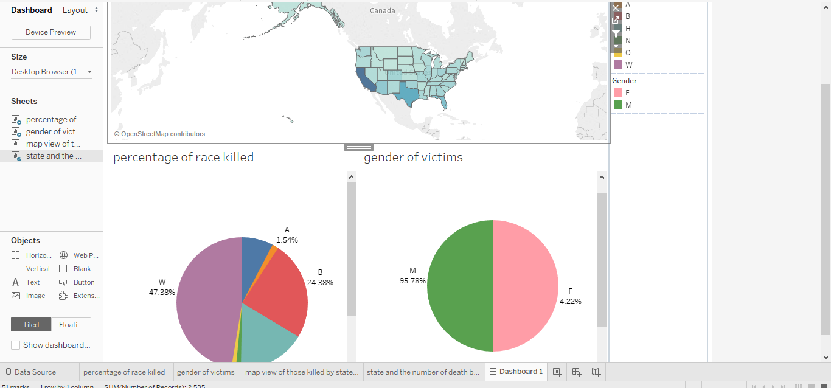

Fig 1.1 final dashboard1 created and filtered by the states

Dashboard 1 is showing the percentage of race killed and the gender in each state. We can filter the results by each state. This is necessary as majority of the blacks believe they are killed by police due to racial profiling. From the dashboard created we filter all results by each state and we can view the most race and gender that has been killed by police officer in each state.

It seems that Whites killed were spread throughout most of the country. Black people seem to make up the lion’s share of the deceased near the crime riddled areas of Baltimore, DC, and Chicago. Hispanics/Latinos understandably made up more of those killed in Hispanic/Latino population heavy states like California, New Mexico, and Texas, and also made up most of the deceased in border towns by Mexico. Southern California seems to have had a heavy combination of all 3 of the mentioned races/ethnicities. Native American deaths seem to have had the highest concentration near/at the Native American reservations of Arizona and New Mexico.

You may notice that black people made up a disproportionately large share (more than 24%) of those killed, while comprising of only 12% of the overall American population. However, trying to find meaningful conclusions purely based on these statistics would mean we are ignoring the confounding factors behind them. According to FBI reports, the homicide rate for black males is 8 times higherthan white males. Other people may be tempted to prematurely conclude that higher crime rates are the explanation to black people getting killed at a higher rate. But again, to reach conclusions about a race/ethnicity based on snippets of a dataset like this would not only be incorrect, but also dangerously ignorant. We would be breaking the Golden Rule of Observational Studies: **Correlation does not equal Causation**. A deeper level of confounding factors such as poverty rate, educational background, and socioeconomic status could arguably much better predict incidences of violent crime among groups.

Target Audience: Mayors, community leaders, law enforcement agencies, citizens

This dashboard can benefit decision making process by providing an avenue where by community leaders and citizens can interact with officers of the law and educate them on the rules of engagement.

The following screen shots below show the creation of dashboard 1. The final dashboard is displayed in fig 1.1

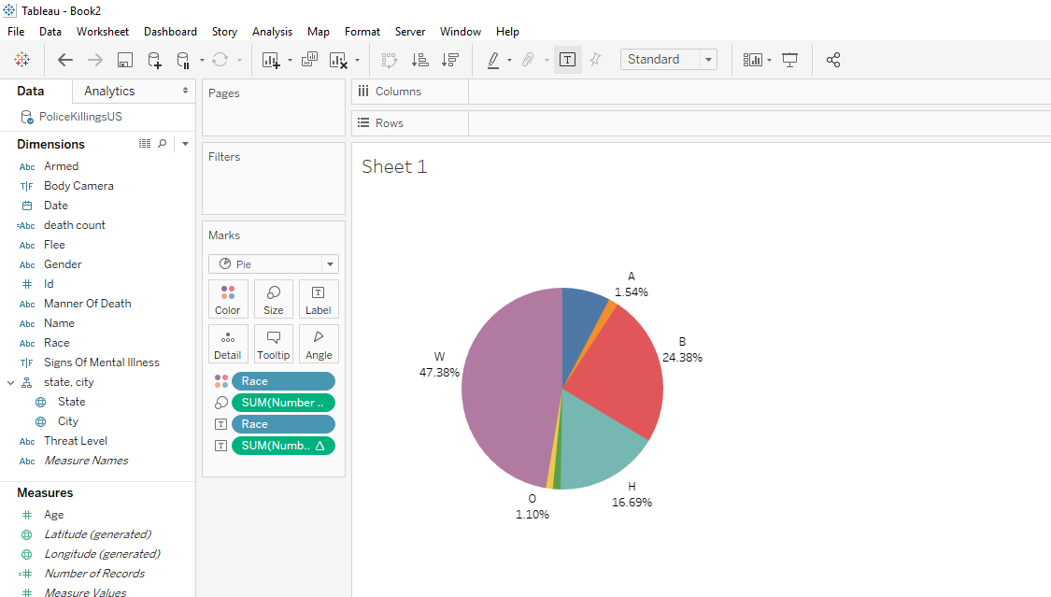

Fig 1.1 first sheet of dashboard 1. Pie chart showing the percentage of ethnicity killed

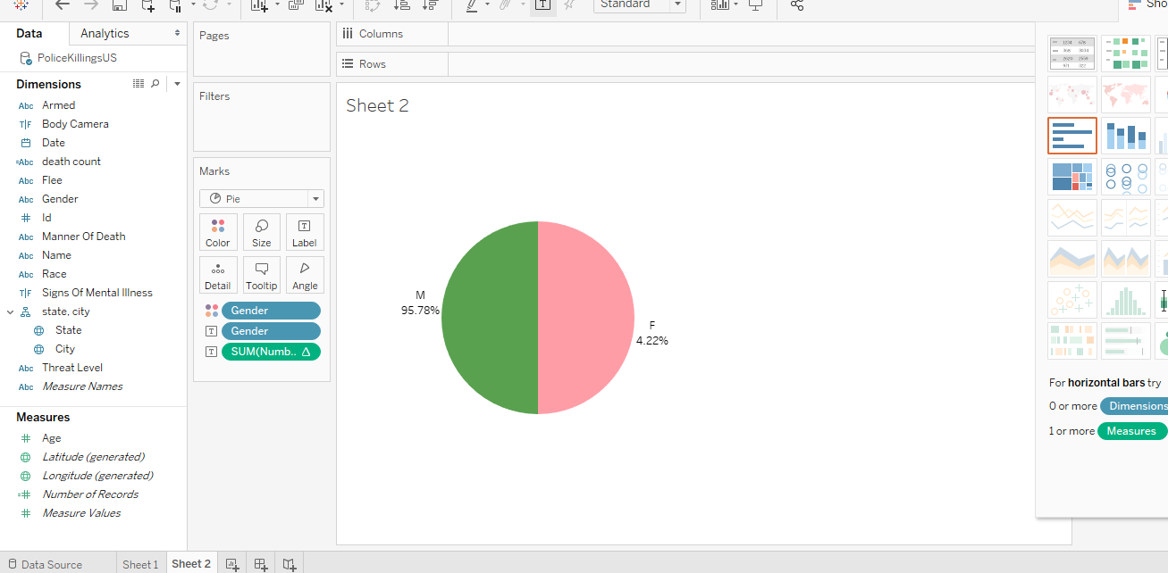

Fig 1.2 second sheet of dashboard 2. Pie chart showing the gender of the deceased.

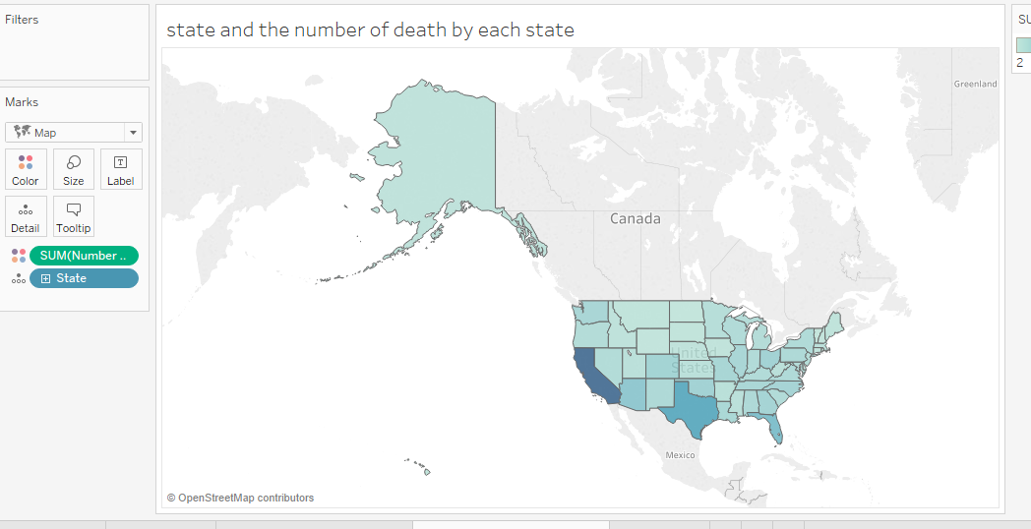

Fig 1.3 a 3rd sheet showing map view of the number of dead victims by each state

**Dashboard 2:**

Here, we are trying to view the sign of mental illness cases amongst the deceased and their age group. We can also filter by states.

From our dashboard created, we can see the percentage of mental illness case was almost 25%. This is huge considering the fact that approximately 1 in 25 **adults** in the **U.S.** (11.2 million) experiences a serious **mental illness** in a given year that substantially interferes with or limits one or more major life activities. Approximately 1 in 5 youth aged 13–18 (21.4%) experiences a severe **mental disorder** at some point during their life (Serious Mental Illness (SMI) Among Adults. (n.d.). Retrieved May 13, 2019).

The main issue here is creating mental illness awareness amongst officers and the general public. Officers need to approach suspects who show signs of mental illness with more caution and empathy instead of the aim to shoot and kill. This was the suspect can get the help he/she required.

Training seminars can be organized for law enforcement agencies on educating them on mental illness, how to notice signs of mental illness exhibited by the suspects and how to calm such suspects down.

Target Audience: law enforcement agencies, World health organization, and national institute of mental health (NIMH)

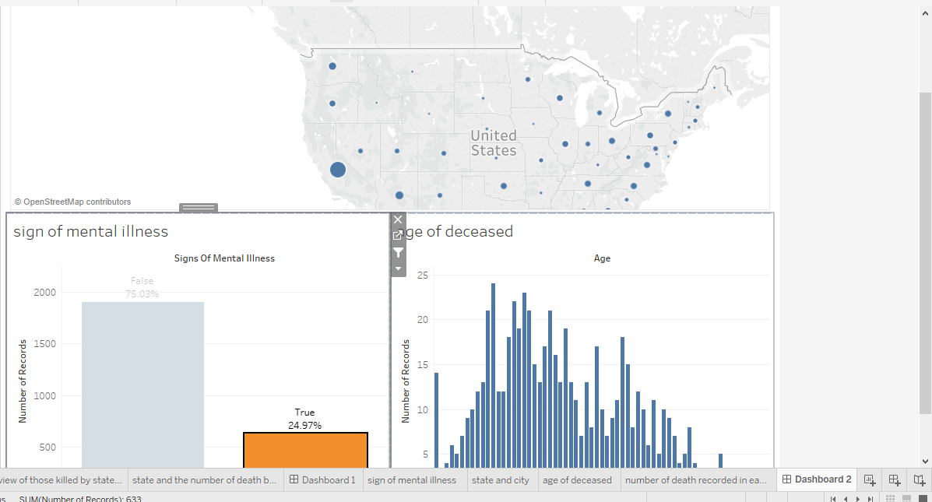

Fig 2.1 Here, we are trying to view the sign of mental illness cases amongst the deceased and their age group. We can also filter by states.

The following screen shots below show the creation of dashboard 2. The final dashboard is displayed in fig 2.1

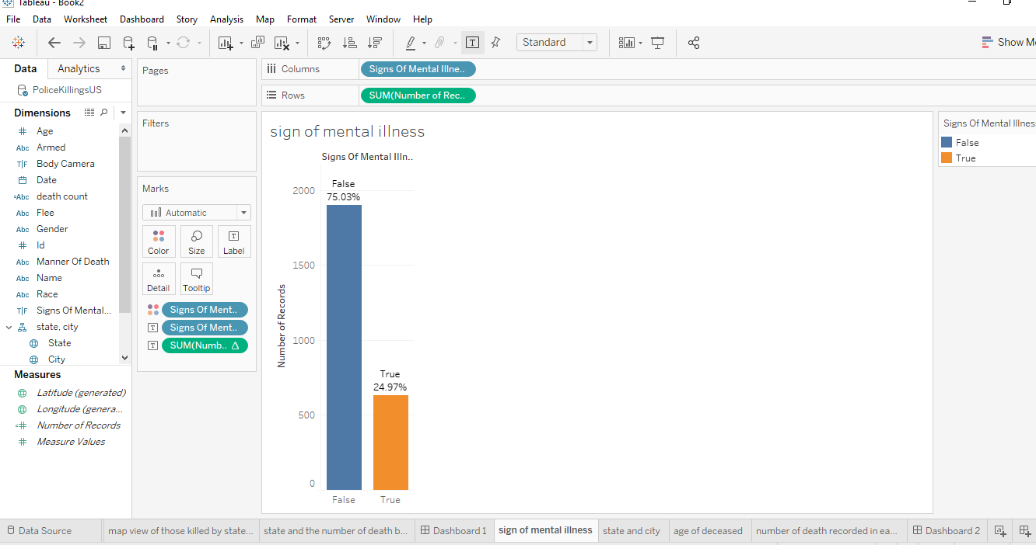

Fig 2.2 a histogram showing the percentage number of victims killed if they had mental illness or not. From the above we can see that the percentage of those who had mental illness is almost 25%. That’s huge considering the fact that nearly one in five U.S. adults live with a mental illness (national institute of mental health 2017).

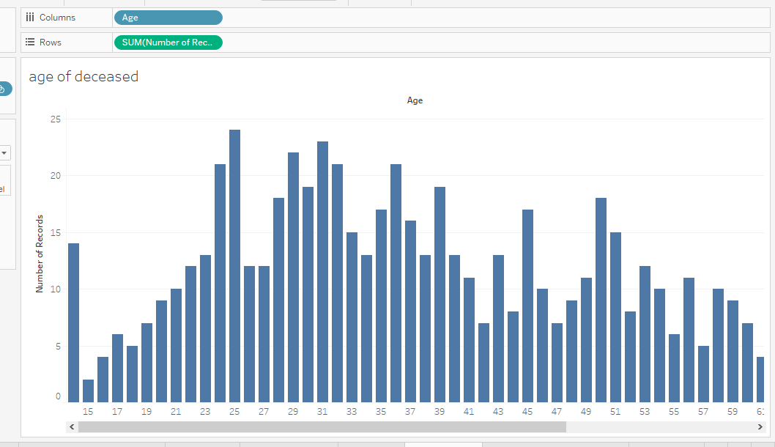

Fig 2.3 Age of the deceased

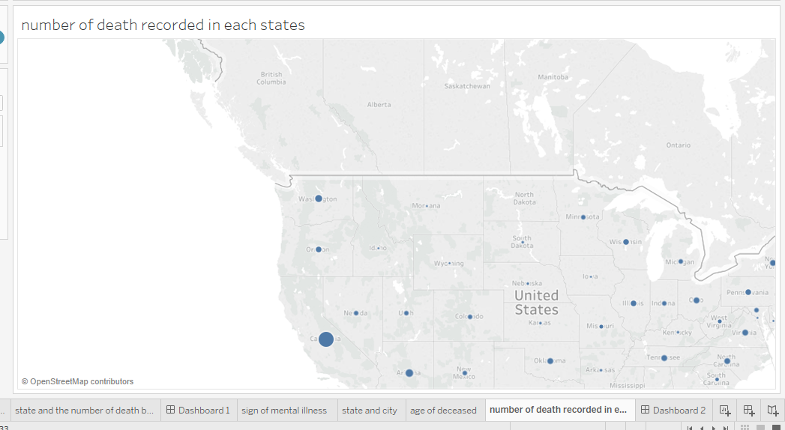

Fig 2.4 Number of deaths recorded in each state

**Dashboard 3**

For the map below, we are looking at all police killings during 2015 and filtering with the age of the deceased. If you notice the dots in the Kentucky, Tennessee, Virginia, North Carolina area, it seems that those killed there were slightly older than others killed elsewhere. The second insight, which should be obvious to you if you are familiar with the US map, is that the killings were concentrated in the cities, with bigger cities accounting for higher concentrations. No big surprise there.

Target Audience: Mayors, community leaders, law enforcement agencies, citizens

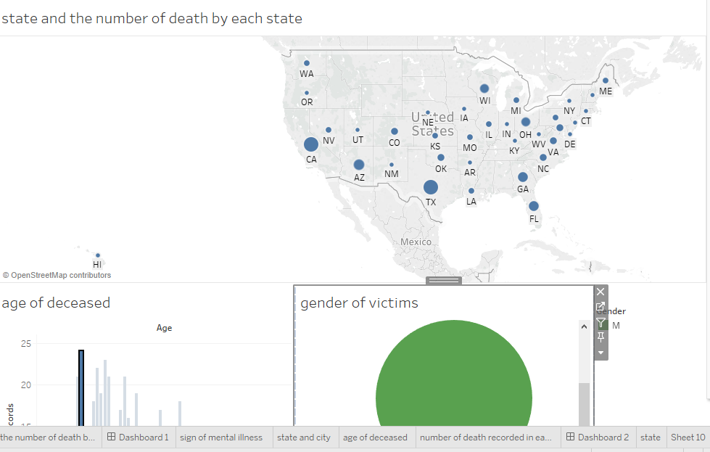

The following screen shots below show the creation of dashboard 3. The final dashboard is displayed in fig 3.1



Fig 3.2 Age of the deceased

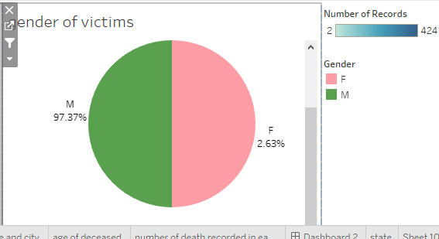

Fig 3.3 Gender of the victims filtered by age

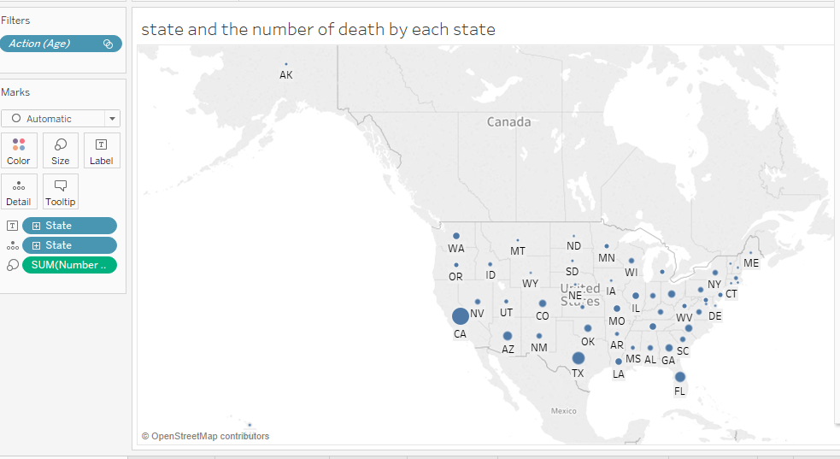

Fig 3.4 States where the victims where shoot by police officers.

**Dashboard 4**

This dashboard shows the unarmed victims in each state and whether they were shot or not and try to understand the rational why an officer of the law will shoot an unarmed civilian.

The essence of this dashboard is the wide spread postulation of police brutality in some parts of the United States. If the data is representative of what’s still happening now, then it seems that the killings of unarmed individuals are also a wide-spread problem throughout the US. Gunshots seemed to be the leading cause of death here as well (gunshots are responsible for over 90% of the killings in 2015)

This dashboard can help law enforcement agencies better train their officers on how to handle citizens who are unarmed and not use force while trying to arrest them. Teasers can be used or just simply tackling the individual. It can help improve the decision making of officers.

Target Audience: Mayors, community leaders, law enforcement agencies.

Now let’s investigate how race/ethnicity factors into the picture (done in dashboard 5).

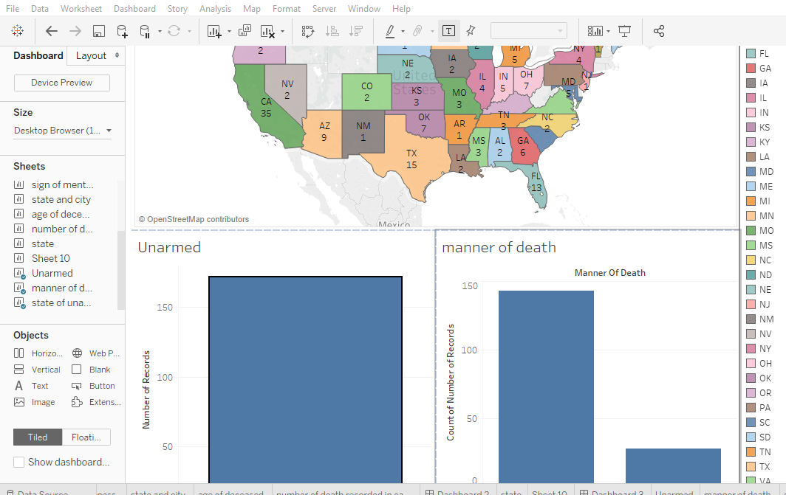

Fig 4.1 Unarmed victims (filter) in each states (also a filter) and the manner of death (whether they were shots or not).

The following screen shots below show the creation of dashboard 4. The final dashboard is displayed in fig 4.1

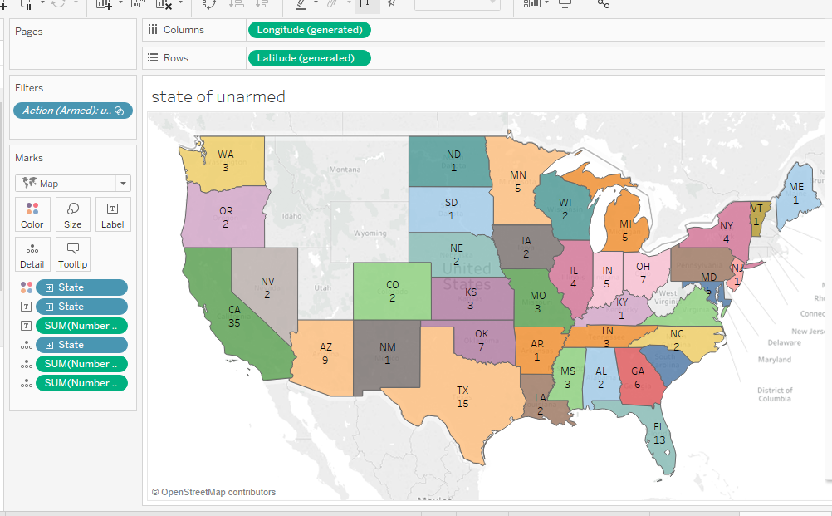

Fig 4.2 State and the number of records of unarmed deceased.

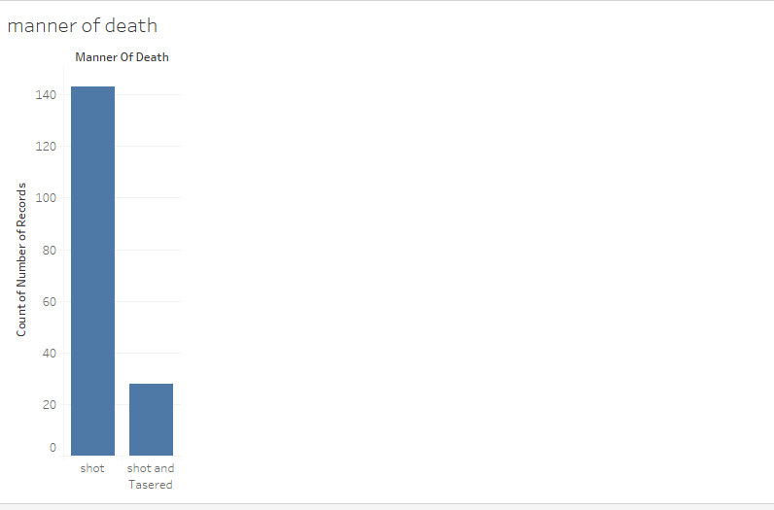

Fig 4.3 Manner of death (shoot or shoot/tasered) filtered by armed.

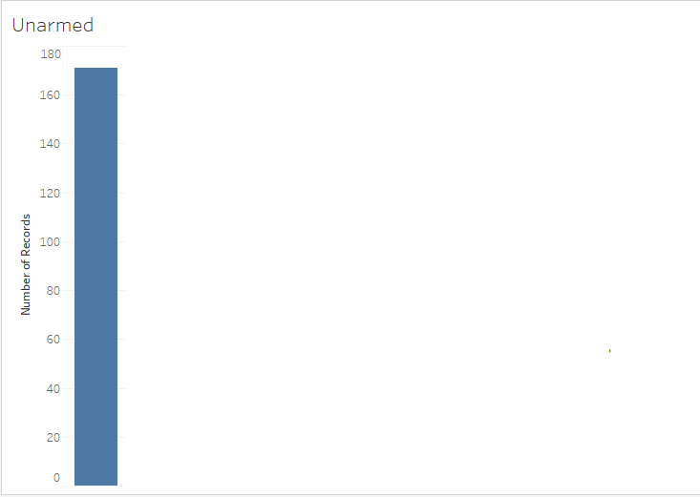

Fig 4.4 Unarmed victims of the entire population of the dataset.

Now let’s investigate how race/ethnicity factors into the picture.

**Dashboard 5**

This dashboard is linked with the dashboard above but here it’s investigating how race/ethnicity factors into the picture. It is showing the states and unarmed deceased and the percentage of race/ ethnicity killed.

The deaths of **Michael Brown**, **Eric Garner**, **Walter Scott**, and **Freddie Gray** are - some claim - evidence of long-standing problems with police racism and excessive violence.

Black people seem to make up the lion’s share of the deceased near the crime riddled areas of Baltimore, DC, and Chicago. Hispanics/Latinos understandably made up more of those killed in Hispanic/Latino population heavy states like California, New Mexico, and Texas, and also made up most of the deceased in border towns by Mexico. Southern California seems to have had a heavy combination of all 3 of the mentioned races/ethnicities. Native American deaths seem to have had the highest concentration near/at the Native American reservations of Arizona and New Mexico.

This dashboard can help law enforcement agencies better train their officers on how to handle citizens who are unarmed and not use force while trying to arrest them. Teasers can be used or just simply tackling the individual. It can help improve the decision making of officers.

Target Audience: Mayors, community leaders, law enforcement agencies.

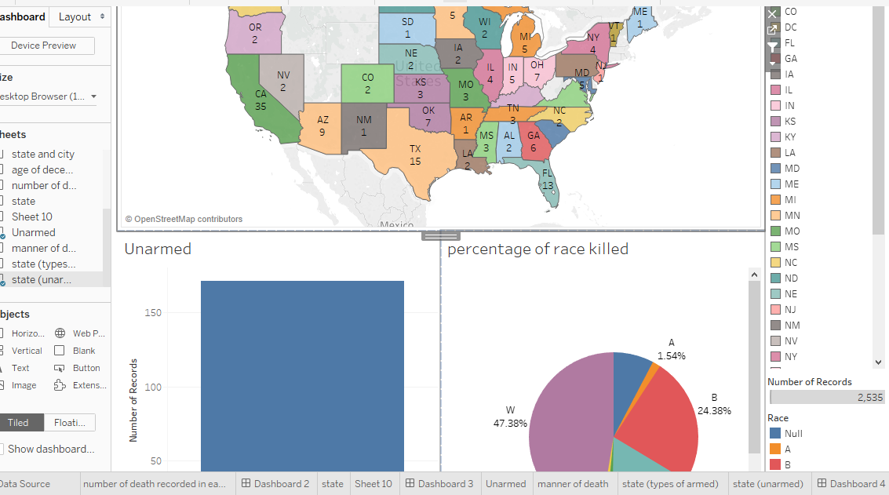

Fig 5.1 a dashboard showing the states and unarmed deceased and the percentage of race/ ethnicity killed.

The following screen shots below show the creation of dashboard 5. The final dashboard is displayed in fig 5.1

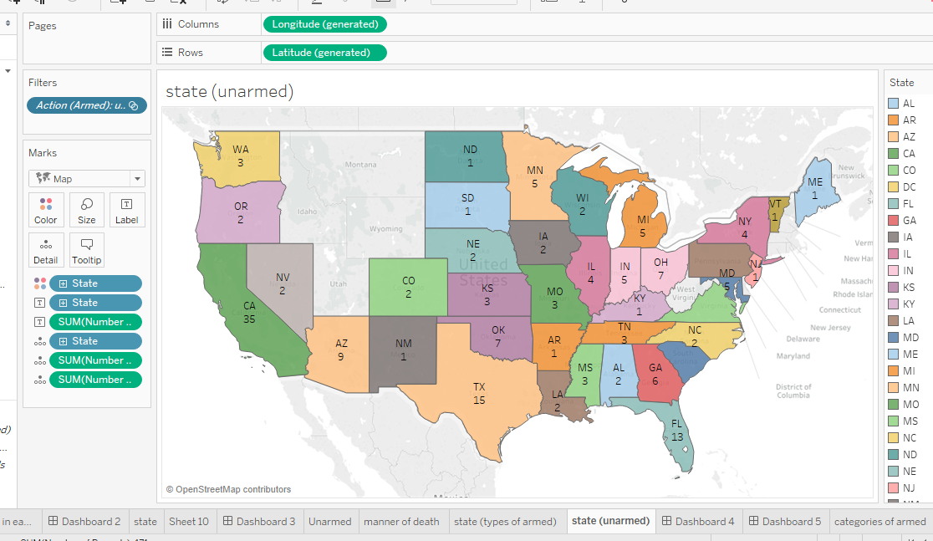

Fig 5.2 States with the number of unarmed deceased who were shot and killed

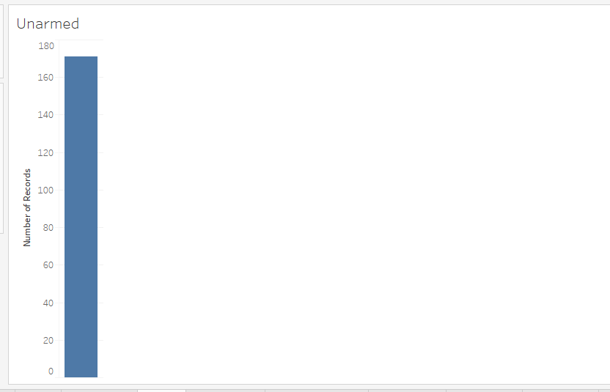

Fig 5.3 Filtered unarmed victims



Fig 5.4 Percentage of the race/ethnicity of the deceased.

**Dashboard 6**

This dashboard shows the type of weapon the deceased was holding before they were shoot by the officers.

From the dashboard below, guns was the most popular weapon held by the deceased as it accounts for 55.15% of the total categories of weapon. This is a huge amount and this shows the major problem of America which is gun control. California has the most cases, followed by Texas.

Following a series of mass shootings in the US in recent years, there has been little in the way of sweeping gun-control reforms.

On the federal level, at least, the interest and attention in new legislation has led to almost no action in decades, despite numerous polls showing widespread public support for measures like strengthened background checks and banning certain types of high-capacity gun magazines and military-style assault rifles.

They can follow New Zealand’s lead and ban guns in the states. .

This dashboard can help decision makers like the United States government, senators and legislators in providing strict controls to gun regulation or just follow New Zealand’s lead and ban guns

Target Audience: united state government, senators, legislators and law enforcement agencies.

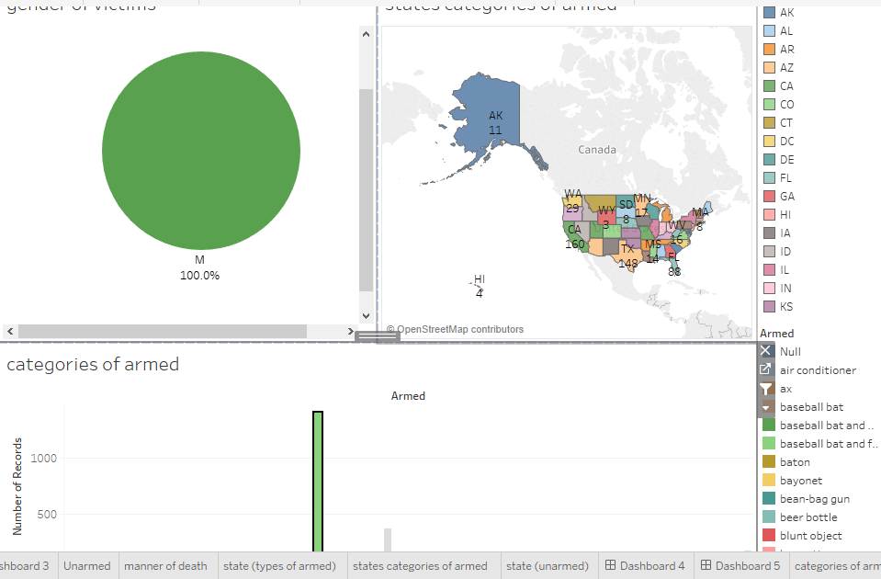

Fig 6.1 dashboard of what kind of armed weapon the deceased was with before they were shot, their gender and filtered by each state.

The following screen shots below show the creation of dashboard 6. The final dashboard is displayed in fig 6.1

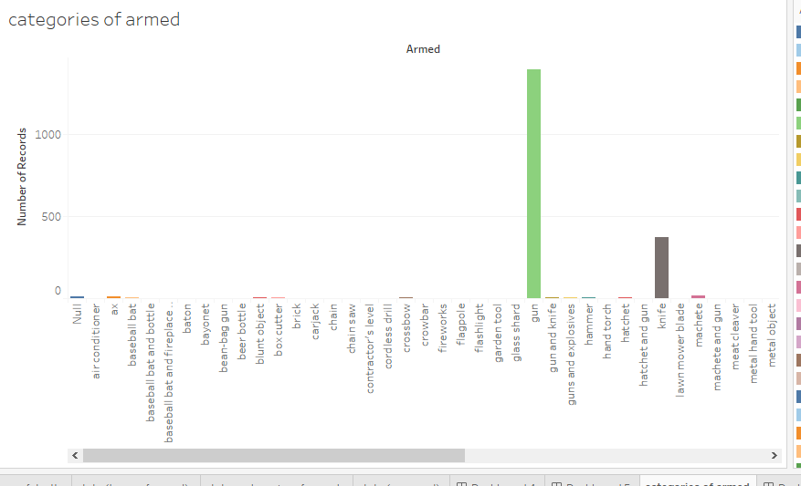

Fig 6.2 what armed weapon was the deceased carrying before they were shot.



Fig 6.3 Gender of the victims filtered by states and what kind of weapon the deceased was holding before being shot.

**Dashboard 7**

Here we are trying to analyze if the deceased flee or not and tried to resist arrest, if they were unarmed and the total count in each states.

The most concern here are victims who were not armed and where not fleeing but they were shoot either way. What judgment did the officer use to decide he/she needs to take a shot at the victim?

Also victims who are unarmed but fleeing. A case study here would be Walter Scott, a 50-year-old black man, was unarmed, facing away from a white police officer, and haphazardly attempting to flee in North Charleston, South Carolina. That didn't stop the officer, Michael Slager, from firing his gun at least eight times at the fleeing man, killing him.

Image below.

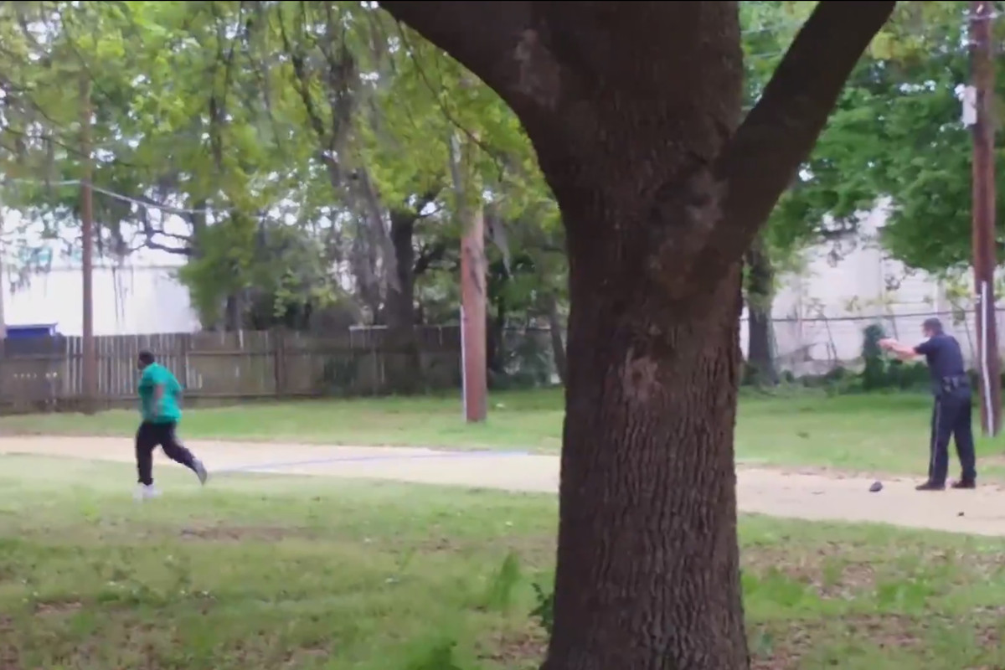

Fig 7.0 a screenshot taken from video of the police shooting of Walter Scott. [*New York Times*](http://www.nytimes.com/2015/04/08/us/south-carolina-officer-is-charged-with-murder-in-black-mans-death.html)

This dashboard could help law enforcement agencies on what to do if a suspect if unarmed and not fleeing or if they are unarmed but fleeing. They could organize re orientation camps for their officers and other weapon handling trainings.

Target Audience: law enforcement agencies

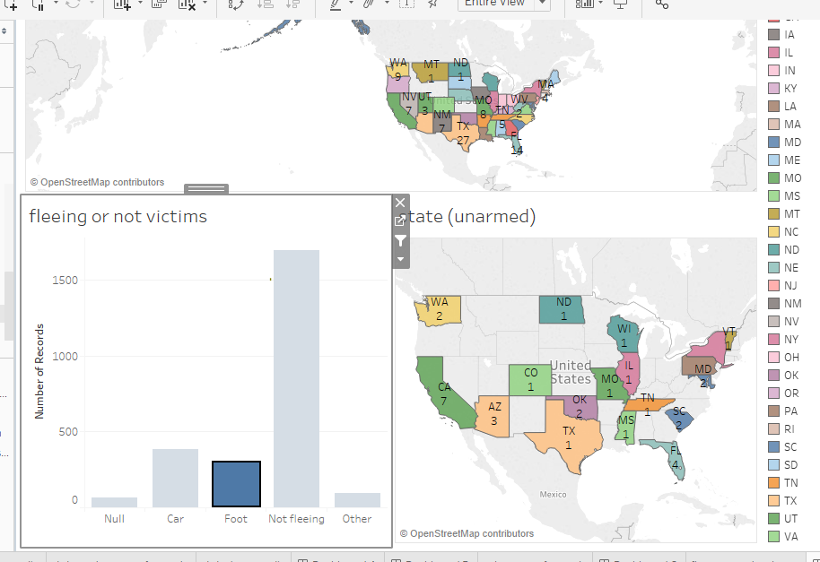

Fig 7.1 here we are trying to analyze if the deceased flee or not and tried to resist arrest, if they were unarmed and the total count in each states.

The following screen shots below show the creation of dashboard 7. The final dashboard is displayed in fig 7.1

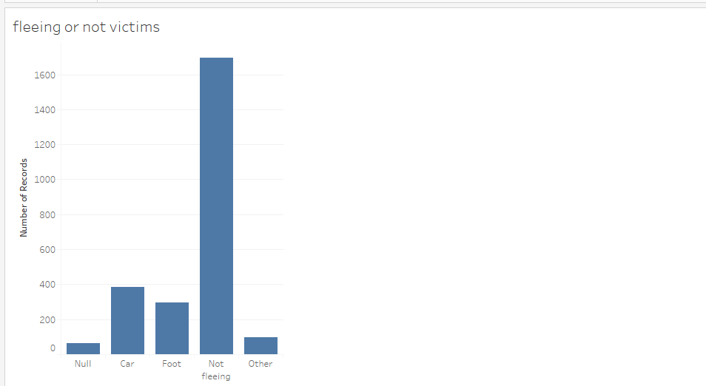

Fig 7.2 fleeing or not fleeing deceased.

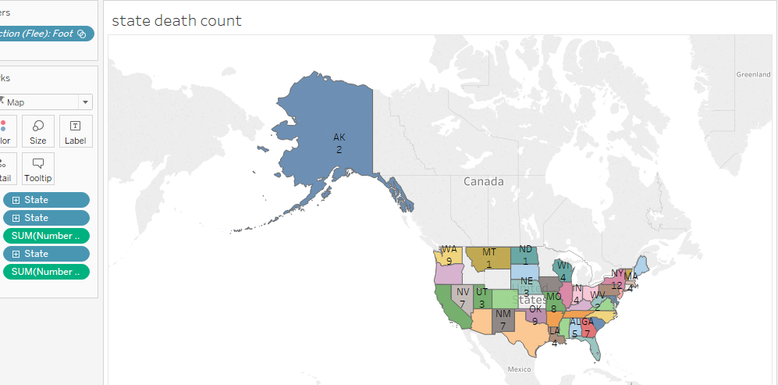

Fig 7.3 state map of the deceased, filtered by the fleeing column.

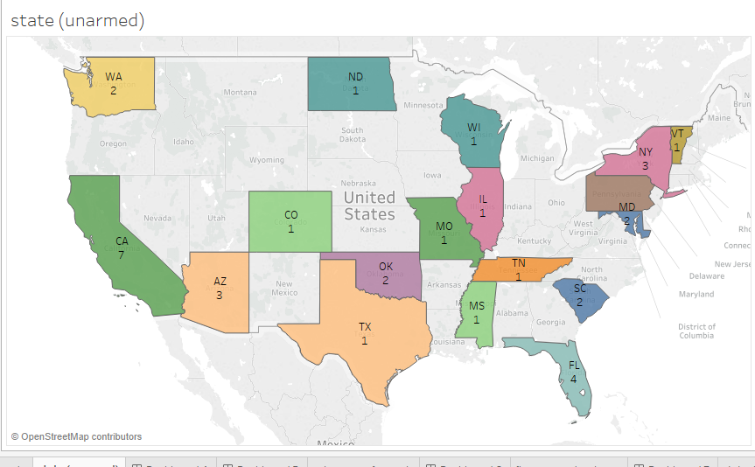

Fig 7.4 all states with unarmed deceased.

**Dashboard 8**

This dashboard links with the above dashboard (dashboard 7) by showing the percentage of ethnicity/race shoot by the police depending if they were fleeing or not.

Black people seem to make up the lion’s share of the deceased near the crime riddled areas of Baltimore, DC, and Chicago. Hispanics/Latinos understandably made up more of those killed in Hispanic/Latino population heavy states like California, New Mexico, and Texas, and also made up most of the deceased in border towns by Mexico. Southern California seems to have had a heavy combination of all 3 of the mentioned races/ethnicities. Native American deaths seem to have had the highest concentration near/at the Native American reservations of Arizona and New Mexico.

This dashboard could help law enforcement agencies on what to do if a suspect if unarmed and not fleeing or if they are unarmed but fleeing. They could organize re orientation camps for their officers and other weapon handling trainings.

Target Audience: law enforcement agencies, citizens, community leaders and mayors

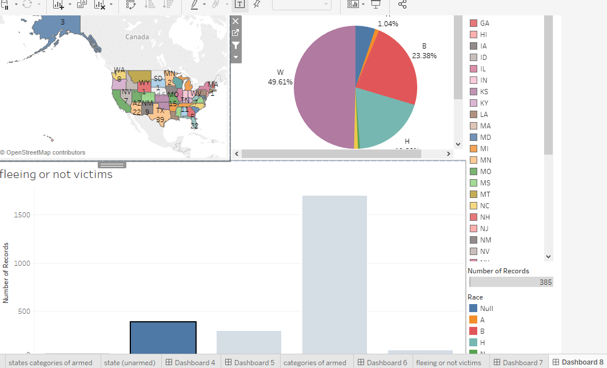

Fig 8.1 dashboard showing the percentage of ethnicity/race that was killed depending if they were fleeing or not

The following screen shots below show the creation of dashboard 8. The final dashboard is displayed in fig 8.1



Fig 8.2 fleeing or not fleeing deceased.

**Dashboard 9**

In this dashboard we are trying to figure out whether or not the officers involved in the shooting turned on the body camera during the shooting. Filtered by states and manner of death.

On a general overview we can see that the officers didn’t turn on their body camera with a staggering rate of 89.3% and they turn it on 10.69%. That’s a huge number. There is no excuse that an officer should turn off their body camera while making an arrest. An example would be the officer who shot and killed 18-year-old Paul O’Neal. The officer was wearing a body camera during the shooting, but the camera was turned off at the time.

# Due to the frequent rate of officers turning of body cameras during shooting, there are plans to make a proposed Tennessee law would make it a felony for police officers to disable their body cams.

# This dashboard can help decision makers such as law makers and legislators to pass bill to prohibit officers of the law from turning of their body camera.

Target Audience: law makers, legislators, senators, United States government, law enforcement agencies, citizens, community leaders and mayors

The following screen shots below show the creation of dashboard 9. The final dashboard is displayed in fig 9.1

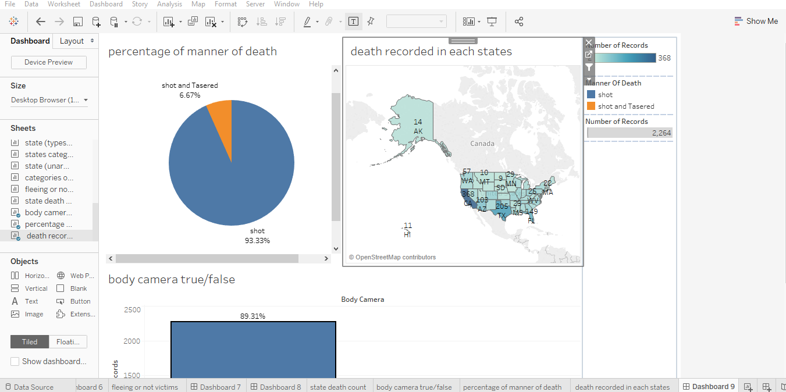

Fig 9.1 In this dashboard we are trying to figure out whether or not the officers involved in the shooting turned on the body camera of their vehicle during the shooting. Filtered by states and manner of death.

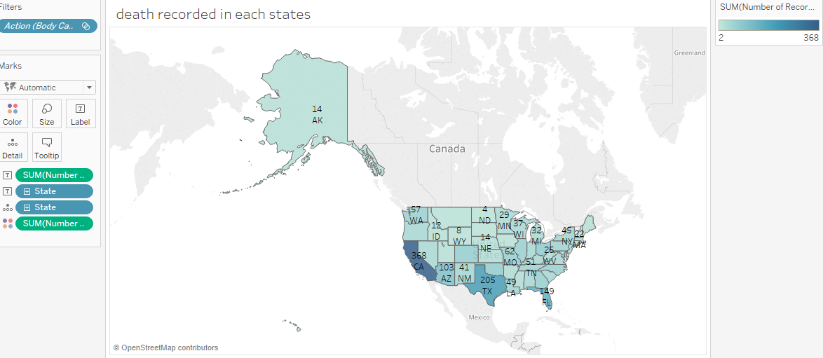

Fig 9.2 death recorded in each state. Filtered by body camera and states

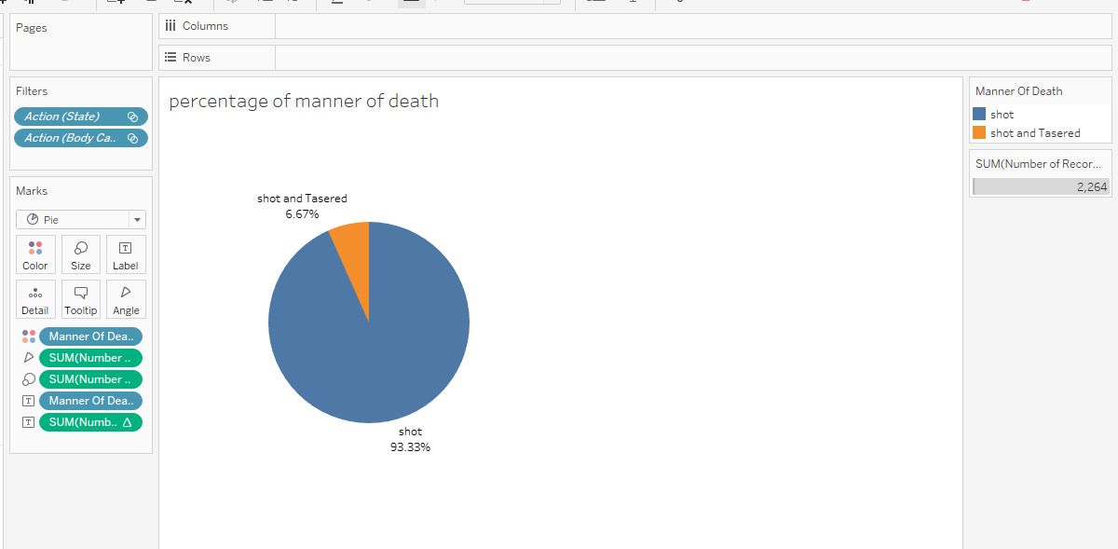

Fig 9.3 percentage of manner of death filtered by body camera and states

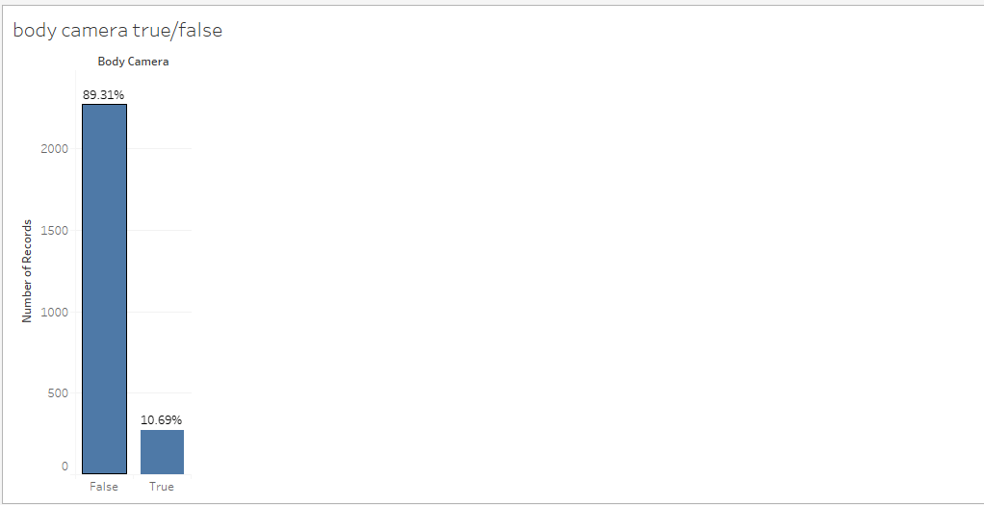

Fig 9.4 Body camera percentage from the above we can see the officers here didn’t not turn on the body camera from their vehicle during the shooting. With a staggering rate of 89.3% and they turn it on 10.69%

**Dashboard 10:**

Here we are trying to see if the level of perceived threat is based on race (racial profiling).

From the dashboard creating we see if the level threat perceived is to attack 50% of the blacks are killed. That’s a huge number considering the percentage of blacked killed by police officers was almost 25%. So it that 50% of those tagged as attack was shoot and killed.

Decision makers can use this dashboard to know the level of threat perceived by officers based on the weapon held by person’s involved and better train they personnel’s on how to deal with the persons involved based on what they armed with.

Target Audience: law enforcement agencies

The following screen shots below show the creation of dashboard 10. The final dashboard is displayed in fig 10.1

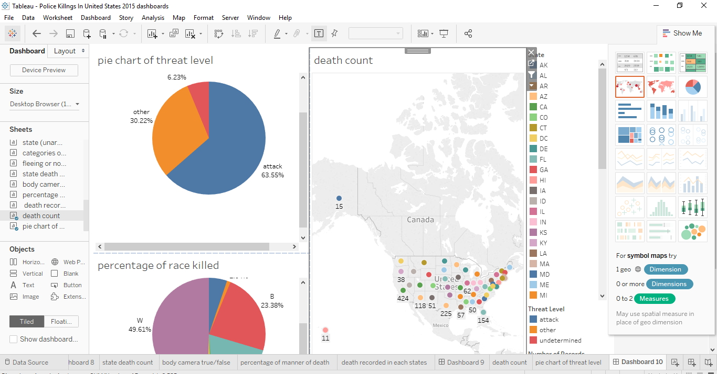

Fig 10.1 Here we are trying to see if the level of perceived threat is based on race (racial profiling).

**Dashboard 11:**

This dashboard links with dashboard 10 above. Here we are trying to know the treat level perceived based on the weapon held by the deceased and if the officers involved in the shooting were justified in shooting the deceased based on the level of threat perceived.

From the dashboard we can see that those who were armed with guns the level of threat perceived was to attack. They were also cases where the deceased where armed with toy guns and they were also shot (thou we can blame this on ignorance from the part of the police).

Decision makers can use this dashboard to know the level of threat perceived by officers based on the weapon held by person’s involved and better train they personnel’s on how to deal with the persons involved based on what they armed with.

Target Audience: law enforcement agencies

The following screen shots below show the creation of dashboard 11. The final dashboard is displayed in fig 11.1

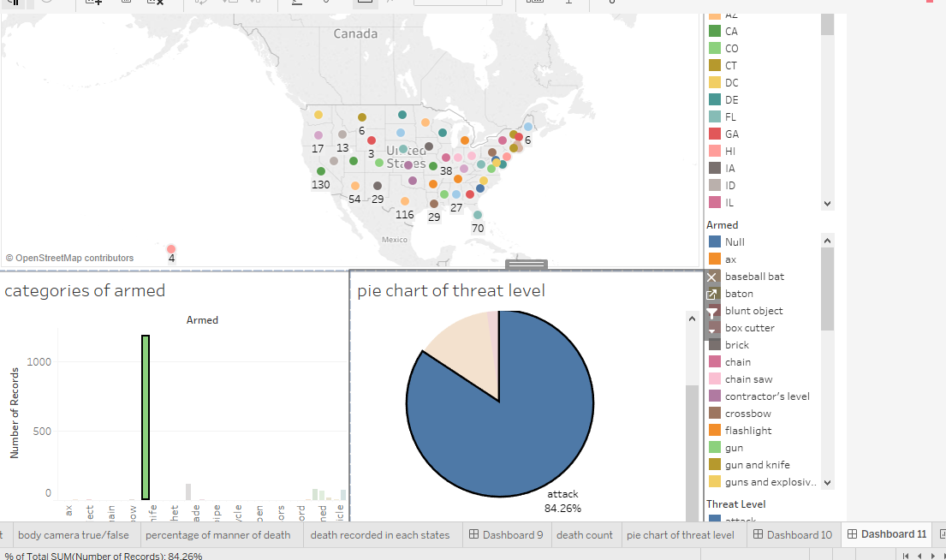

Fig 11.1 Here we are trying to know the treat level perceived based on the weapon held by the deceased and if the officers involved in the shooting were justified in shooting the deceased based on the level of threat perceived.

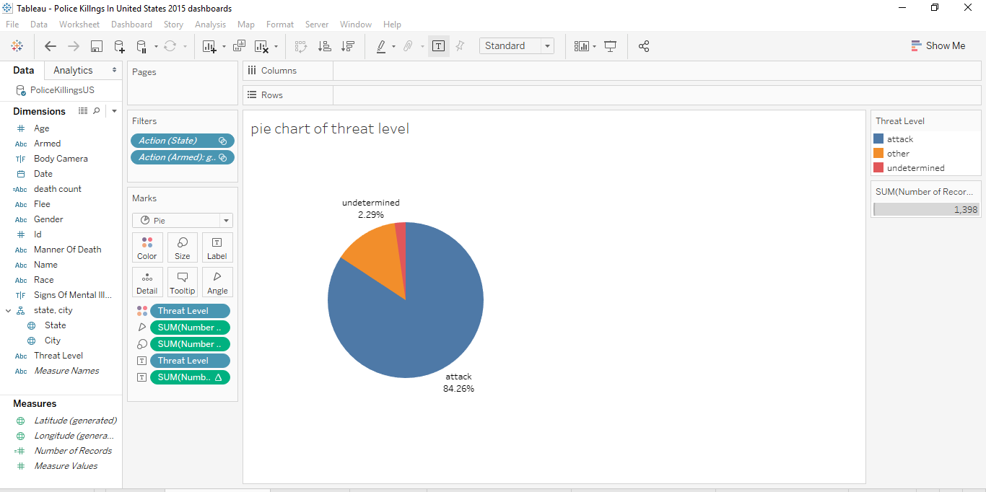

Fig 11.2 pie chart of level of threat perceived by the officers.

**Dashboard 12**

Here we are trying to see the age group of those killed, they gender and we are trying to filter or group them by race.

The age of Hispanics/Latinos killed tended to be lower than that of Whites killed, and Blacks had the lowest median age out of the groups. The median ages for the killed among Whites, Hispanics/Latinos and Blacks were 38, 31 and 30 respectively. However, it is important to note that the median ages for these groups for the general US population are 42.9, 28.1 and 33.3, respectively. That at least explains why the group of Whites killed had the highest median age. The tail end of the graphs for Whites also extended a lot further into older ages, but it’s understandable that they had more outliers as they made up over half the data-set. It’s also worth noting that the median age for Hispanics/Latinos in the US is driven down by the fact that a large portion of their community is 1st generation immigrants who tend to be younger than the US average age. They also tend to have more kids than the other 2 groups.

This dashboard can help community leaders and mayors engage the youths and different age brackets in programs that can benefit them such as vocational trainings, jobs, activities to keep them from crime and off the streets.

Target Audience: citizens, community leaders and mayors

The following screen shots below show the creation of dashboard 12. The final dashboard is displayed in fig 12.1

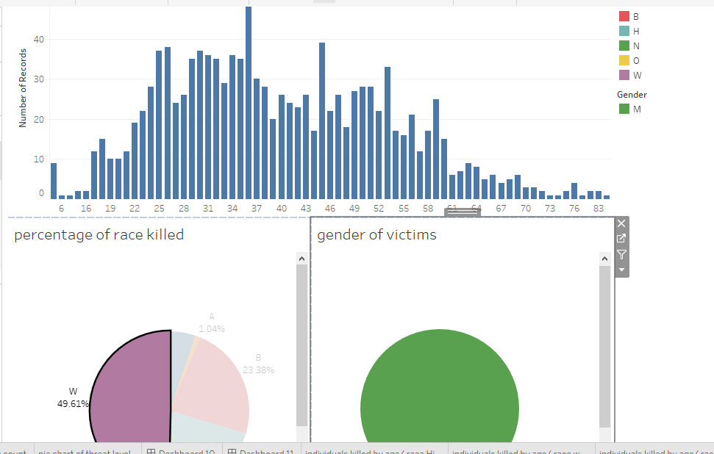

Fig 12.1 Here we are trying to see the age group of those killed, they gender and we are trying to filter or group them by race.

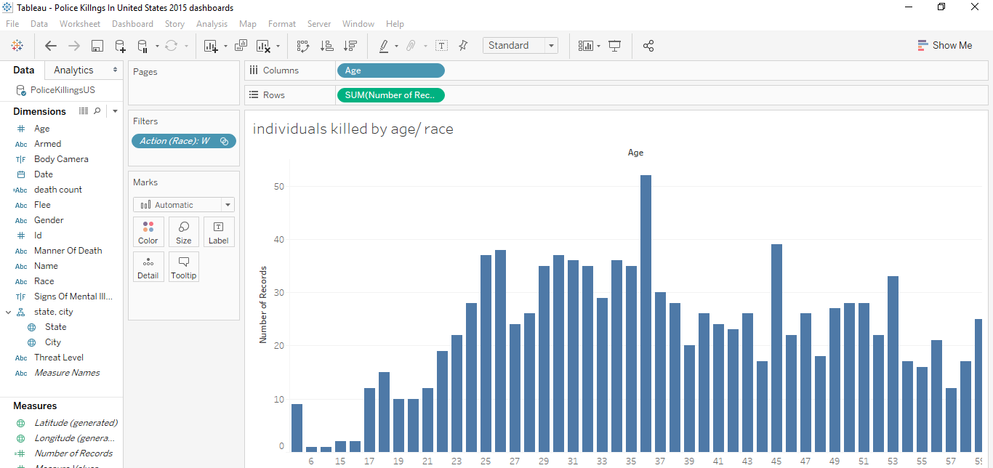

Fig 12.2 Graph showing individuals killed age and then filtered by race.

**Dashboard 13**

In this dashboard we are trying to know the armed status break down by race and try what cause of actions to officer take depending on the race.

If we assume that our data represents the general trends for police killings today, then Black people that are killed are more likely to be armed with a firearm (49.1% were in this case) than any other racial/ethnic group. It would also imply that they are less likely than any other racial/ethnic group to be armed with a knife when killed. More interestingly, if we exclude the 7 Arab-Americans, this would imply that black people are more likely than any other racial/ethnic group to be unarmed when killed (20.9% of black people killed in 2015 were unarmed). These insights, if true, can relate to the highly debated discussion of whether stereotypes associating black people with having firearms lead to more killings of unarmed black people.

Target Audience: citizens, community leaders and mayors, law enforcement agencies

The following screen shots below show the creation of dashboard 13. The final dashboard is displayed in fig 13.1

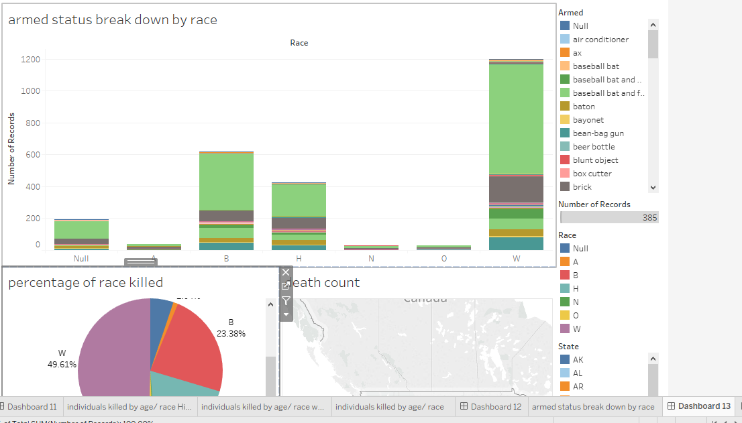

Fig 13.1 in this dashboard we are trying to know the armed status break down by race and try what cause of actions to officer take depending on the race.

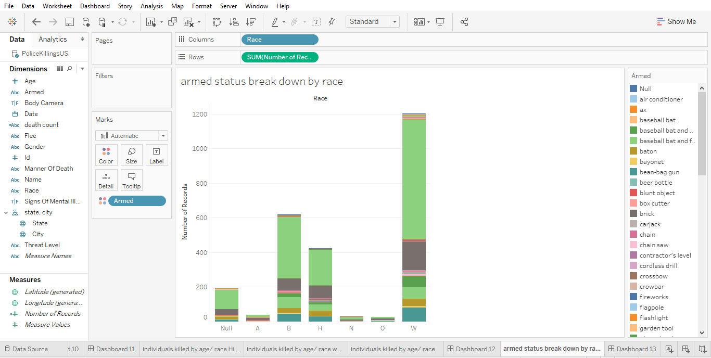

Fig 13.2 armed status bar charts break down by race/ethnicity

**Dashboard 14**

In this dashboard we are grouping each age group by weapons mostly used by them. We are filtering by states and race.

 It intuitively makes sense that the oldest group had the highest percentage of white people. The percentage of white people tends to be higher in older age-groups in the US. The second one is quite interesting. Out of the age-groups, the minors (less than 18) killed had the lowest percentage of cases where they were armed with either a fire-arm or a knife. The under-18 group also had the highest percentage (26.3%) of cases where those killed were unarmed. Note that there isn’t enough information here to conclude that these statistics are reflective of the general population. But if they are found to be representative with further analysis, there should be cause for concern.

This dashboard can help community leaders and mayors engage the youths and different age brackets in programs that can benefit them such as vocational trainings, jobs, activities to keep them from crime and off the streets.

Target Audience: citizens, community leaders and mayors

The following screen shots below show the creation of dashboard 14. The final dashboard is displayed in fig 14.1

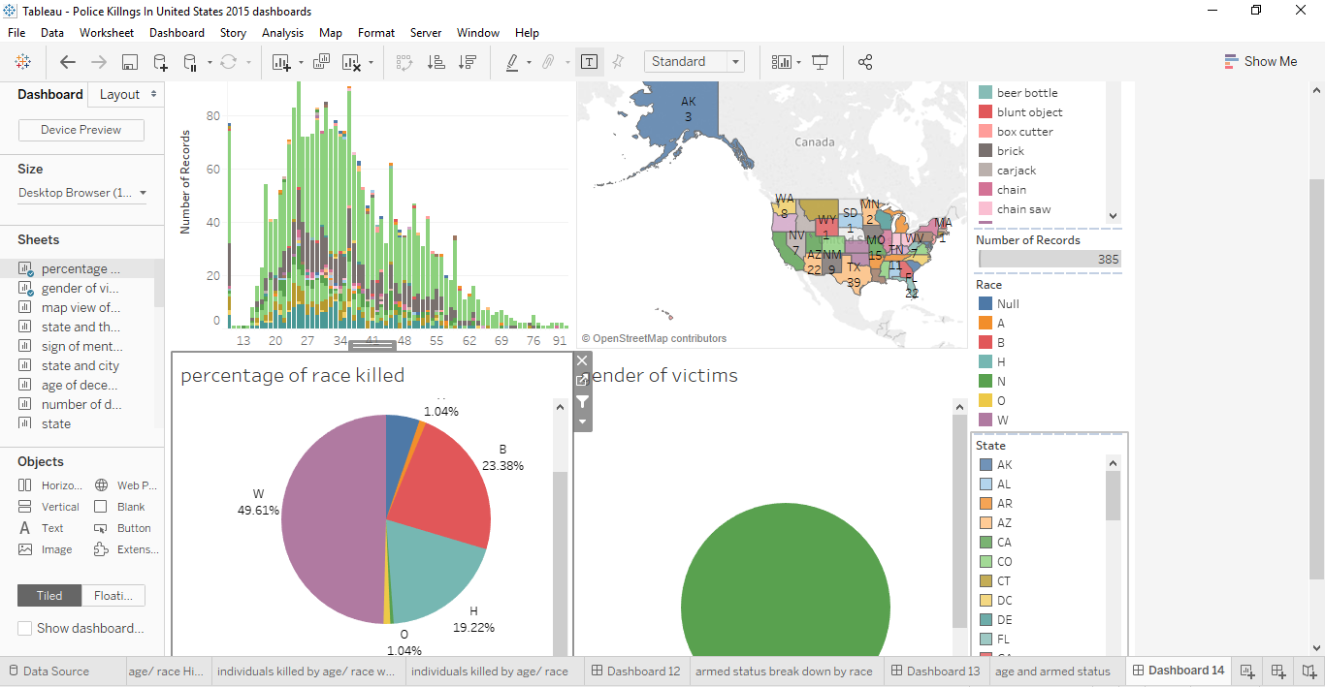

Fig 14.1 in this dashboard we are grouping each age group by weapons mostly used by them. We are filtering by states and race.

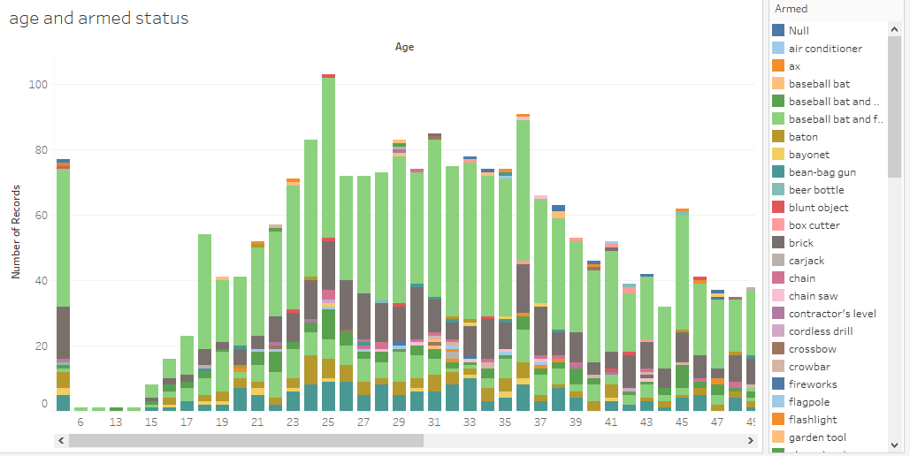

Fig 14.2 age group and armed status bar chart

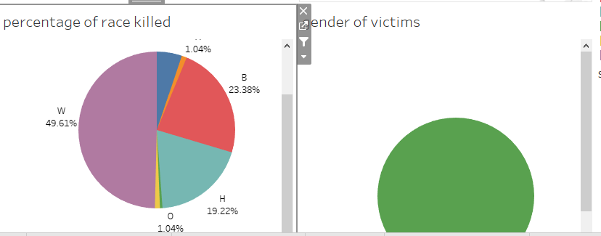

Fig 14.3 Percentage of race Killed and gender.

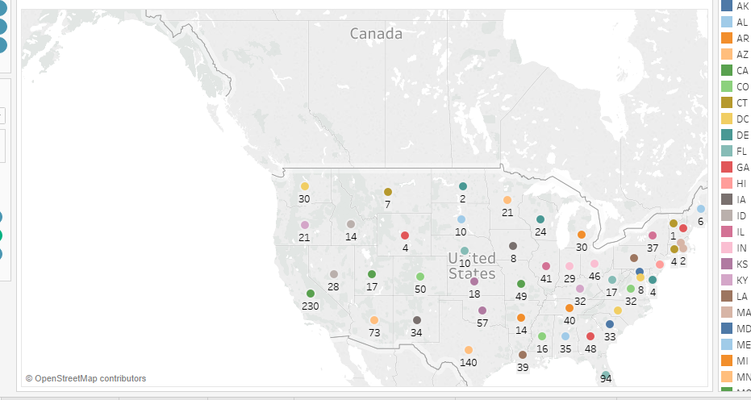

Fig 14.4 all death counts by state.

**Dashboard 15**

In this dashboard we group each killing by month and try to figure out what most had the most killings in each state, cities and what percentage of race or ethnicity was killed.

We can see that there is a cyclic trend here with periods of highs and lows. We cannot say this is a seasonal trend as we only have dataset for one year. We can see there is peak in police shootings in June. We can’t say for certain why there is an increase in June and if we had perhaps other information, we can analyze it better.

Target Audience: citizens, community leaders and mayors, law enforcement agencies

The following screen shots below show the creation of dashboard 15. The final dashboard is displayed in fig 15.1

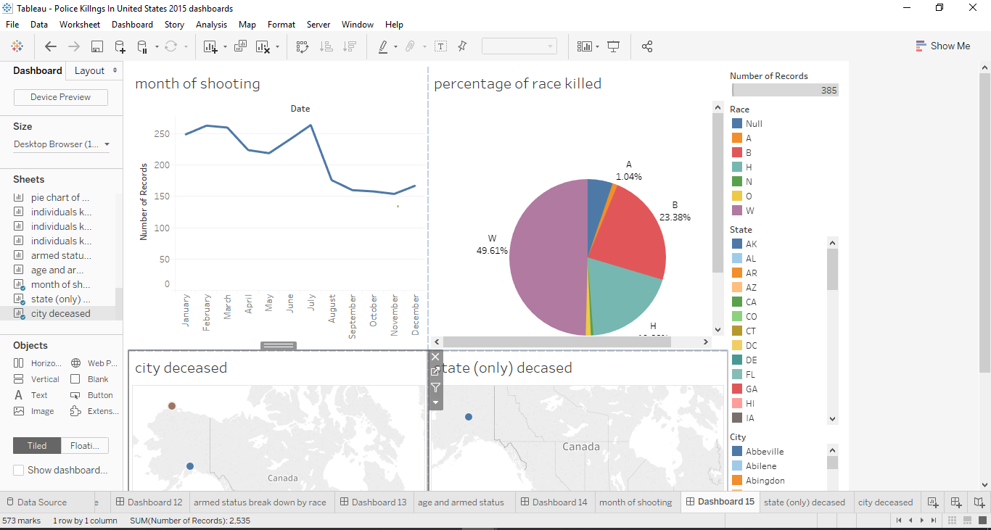

Fig 15.1 in this dashboard we group each killing by month and try to figure out what most had the most killings in each state, cities and what race or ethnicity was killed.

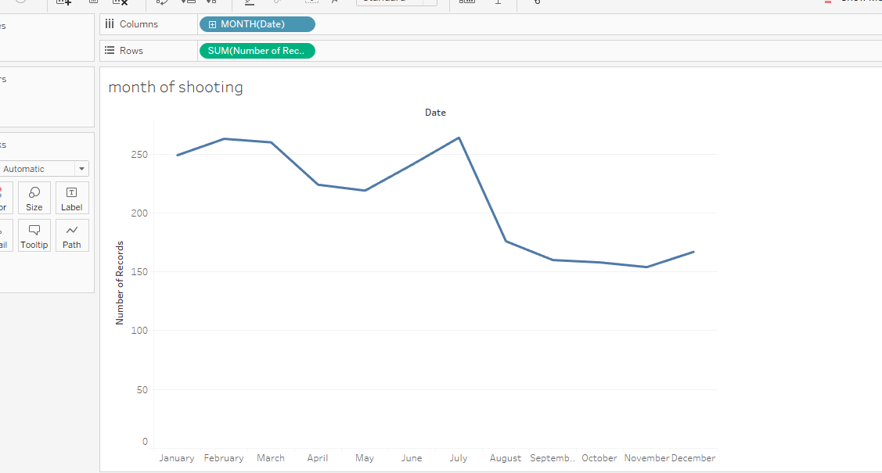

Fig 15.2 Months of the killings

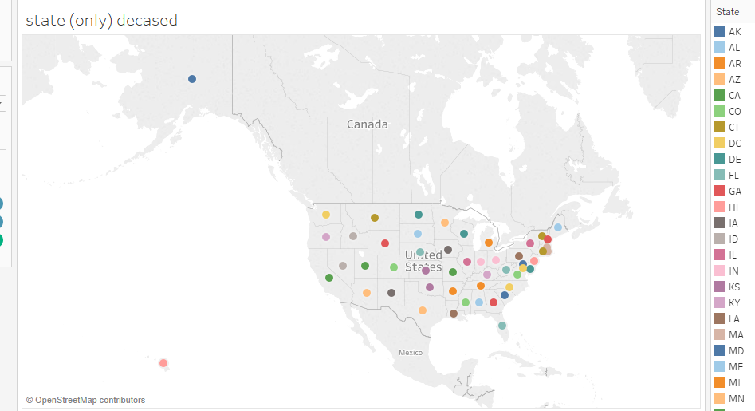

Fig 15.3 State where the deceased were killed

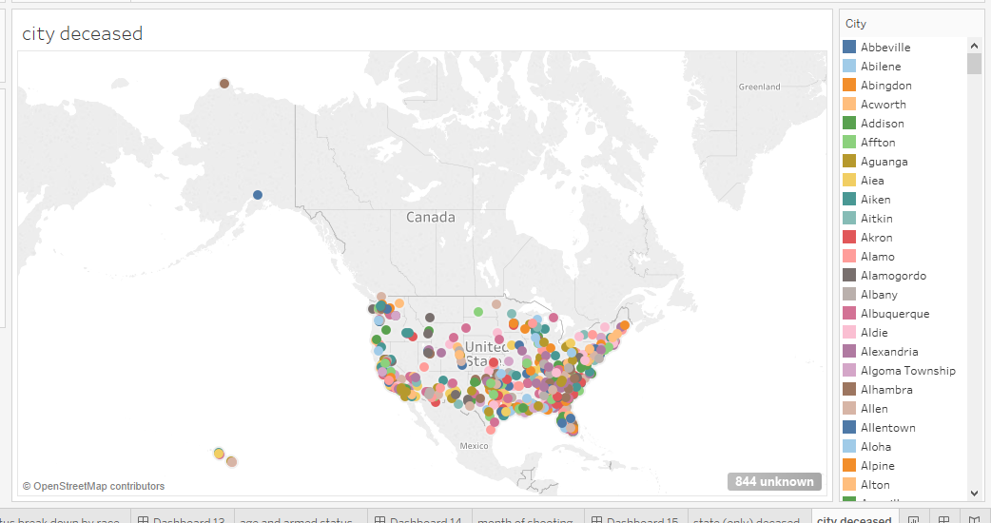

Fig 15.4 city where the deceased were killed

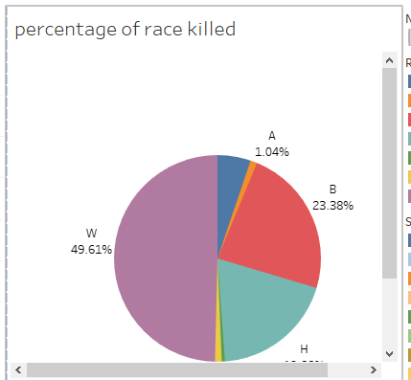

Fig 15.5 percentage of race killed filtered by months

Part II

Predictive Analytics and Visualization of Insights

Various questions that the users of this dataset might have

* If it’s true based wild spread propaganda that blacks are the most killed by police out of all the ethnicity.
* If the killings of unarmed individuals are still a wide-spread problem throughout the US.
* If mental health of the victim was taken into account by the officers. And the need to educate officers on dealing with victims who show signs of mental illness.
* In what area in the United States are they more police killings?
* Are these shootings a case of racial profiling?
* Are the police not trained to do their job properly?
* Percentage of race killed in each states
* What reasons do officer have to turn off their body camera. Is it justified?
* Age group of those being killed. Are they teens? What can be done do take them off the streets?

**The variables with the highest level of relationships using the correlation algorithm in tableau are**

**First I went to the analyze tab and remove aggregate measure. Then drew the trend lines among the variables. The following were attributes had the highest correlation for my dataset**

1. Age and race relationship
2. Date, death count and level of threat
3. The Race and manner of death
4. The Body cam and manner of death count

**Relationship 1 Age and Race Relationship**

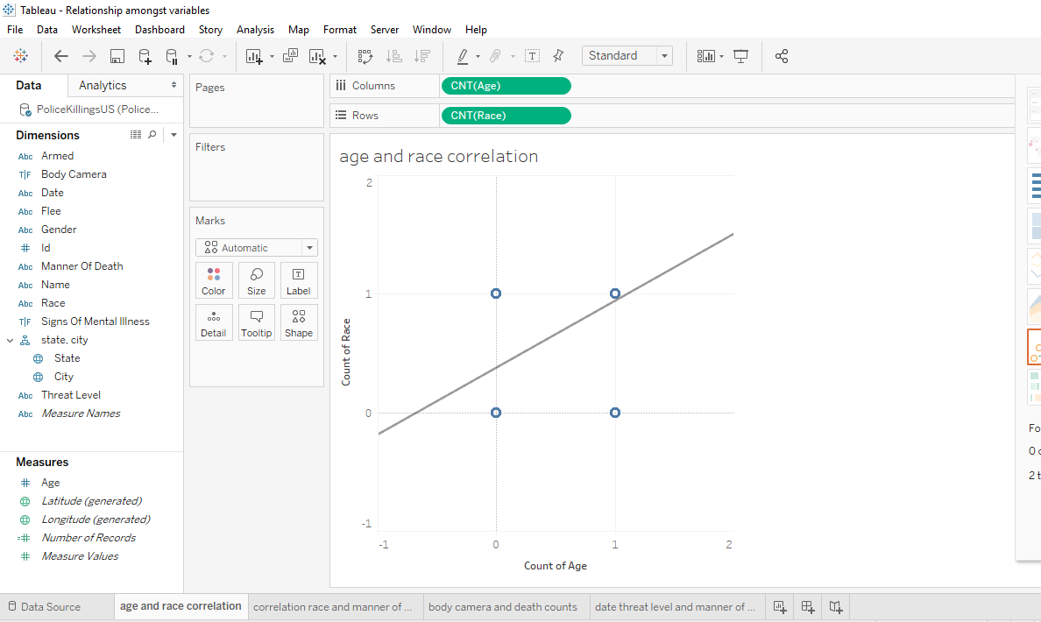

The root mean squared error here was 0.131. We can see there is a relationship between the age variable and the race variable. When we explore it further we have the following insights:

The age of Hispanics/Latinos killed tended to be lower than that of Whites killed, and Blacks had the lowest median age out of the groups. The median ages for the killed among Whites, Hispanics/Latinos and Blacks were 38, 31 and 30 respectively. However, it is important to note that the median ages for these groups for the general US population are 42.9, 28.1 and 33.3, respectively. That at least explains why the group of Whites killed had the highest median age. The tail end of the graphs for Whites also extended a lot further into older ages, but it’s understandable that they had more outliers as they made up over half the data-set. It’s also worth noting that the median age for Hispanics/Latinos in the US is driven down by the fact that a large portion of their community is 1st generation immigrants who tend to be younger than the US average age. They also tend to have more kids than the other 2 groups

**Relationship 2 date, count of manner of death**

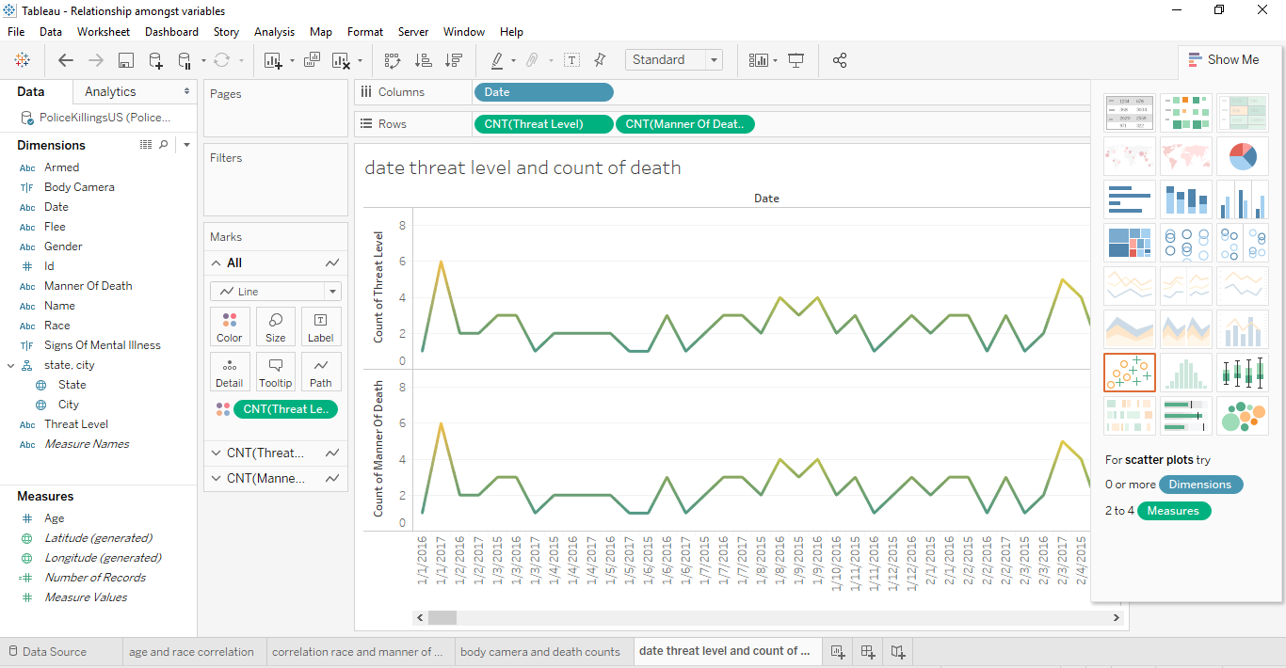

Here can see a relationship between date and death count. It looks like a cyclic trend with periods of high and low. We cannot say this is a seasonal trend as we only have dataset for one year. We are going to explore this further when we are doing a time series analysis of the dataset.

**Relationship 3 of race and manner of death**

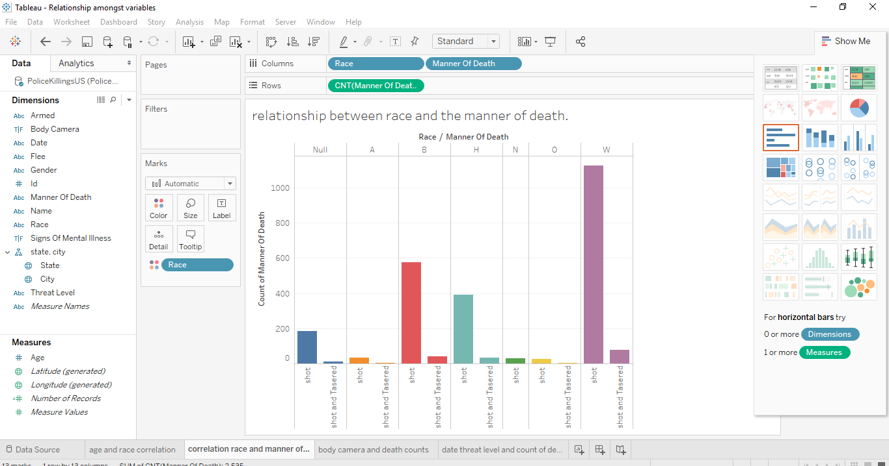

There is also a relationship between race and the manner of death. Earlier we tried to show the number of those shoot because of their race.

**Relationship 4 The Body cam and the manner of death count**

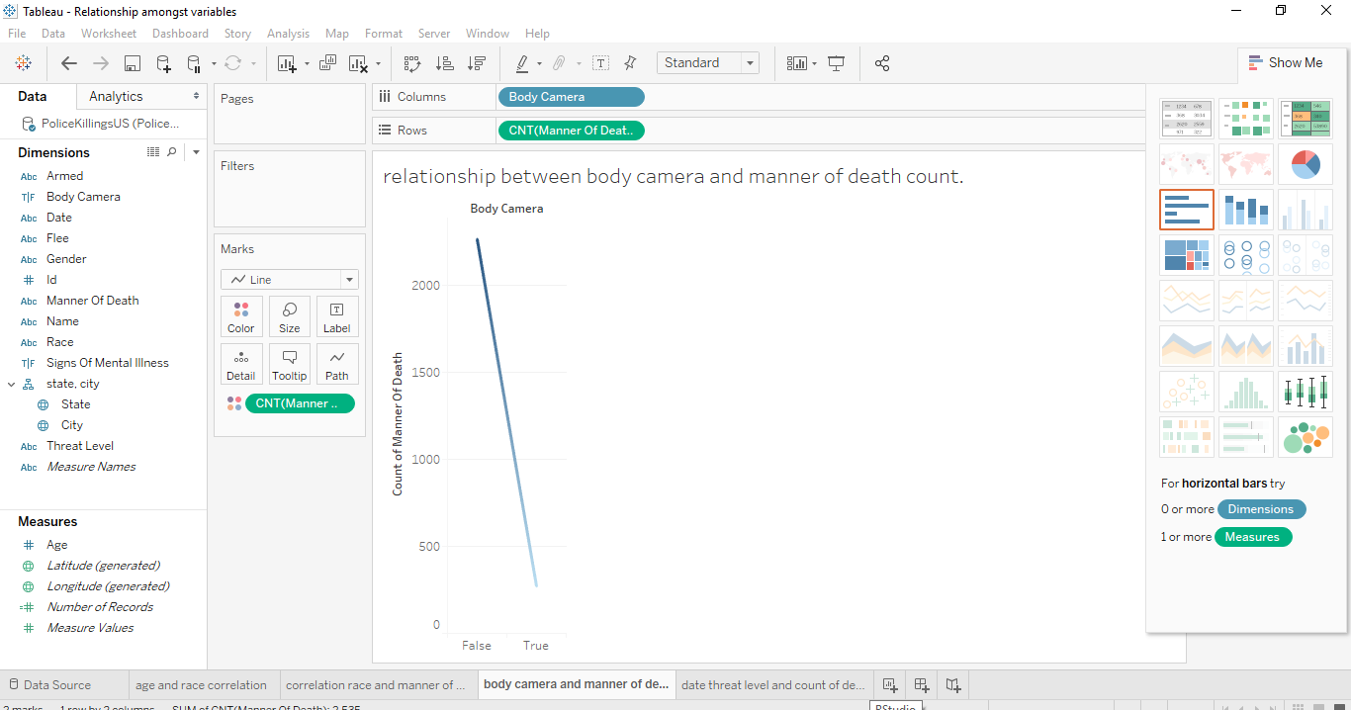

There is a relationship between body camera and manner of death count.

On a general overview we can see that the officers didn’t turn on their body camera with a staggering rate of 89.3% and they turn it on 10.69%. That’s a huge number. There is no excuse that an officer should turn off their body camera while making an arrest. An example would be the officer who shot and killed 18-year-old Paul O’Neal. The officer was wearing a body camera during the shooting, but the camera was turned off at the time.

# Due to the frequent rate of officers turning of body cameras during shooting, there are plans to make a proposed Tennessee law would make it a felony for police officers to disable their body cams.

# PREDICTIVE DATA ANALYTICS

# For the predictive model, tableau forecast function was used to predict the next 3 months of number of police killings in the US. Again this dataset is a cyclic trend, ups and down.

# 

# Our forecast model predicted 3 months from July 2017 - September 2017. It predicted that the number of killings will drop from 84 – 82 in those month periods (based on the historical data provided) with a 95% confidence level.

# A description of our predictive model below

# 

# There was no element of seasonal effects and we ignored the first month with the forecast model based on January 2015 – June 2017.

The next screen shoot shows the cross tab of our forecasted values (orange) and our actual values (blue) as well as the lower prediction and upper prediction

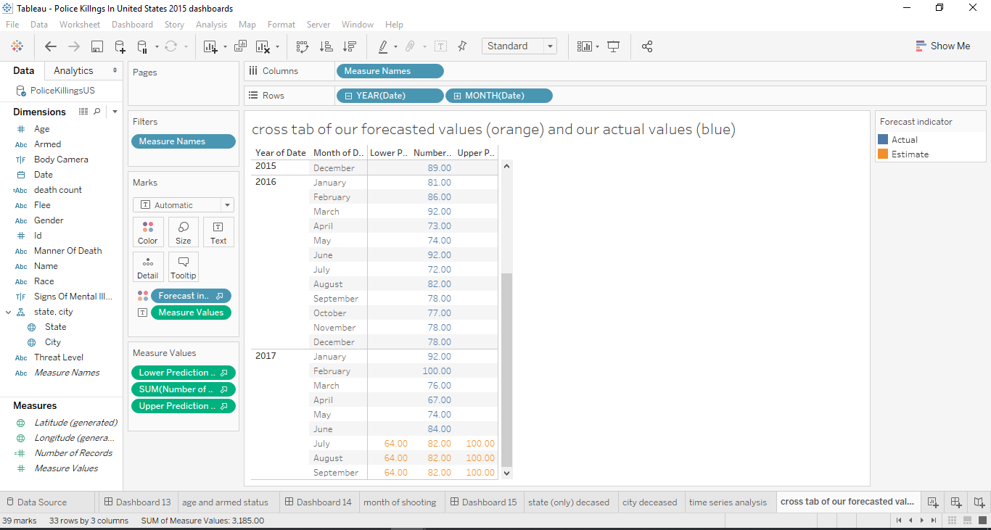

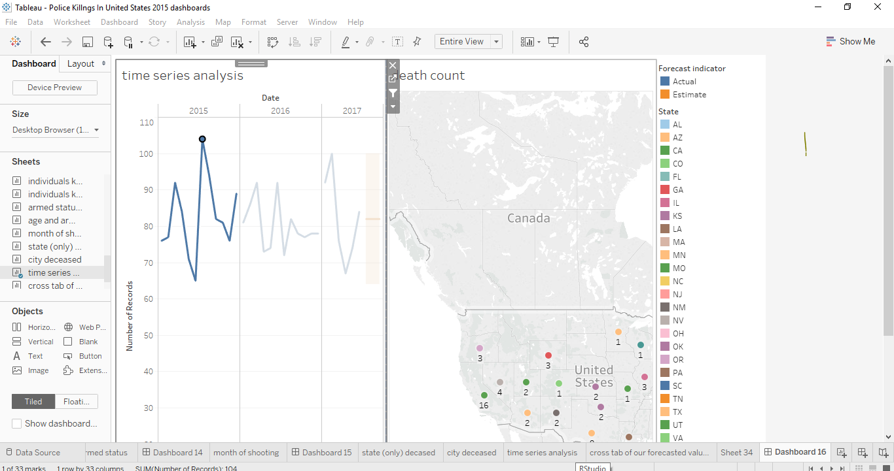

Time series dashboard of time and death count filtered with state and race.

**Forecast prediction of average age based on the year and month given**

# Our forecast model predicted 2 months from July 2017 – august 2017. It predicted that the average age killed will be 36.796 in those month periods (based on the historical data provided) with a 95% confidence level.

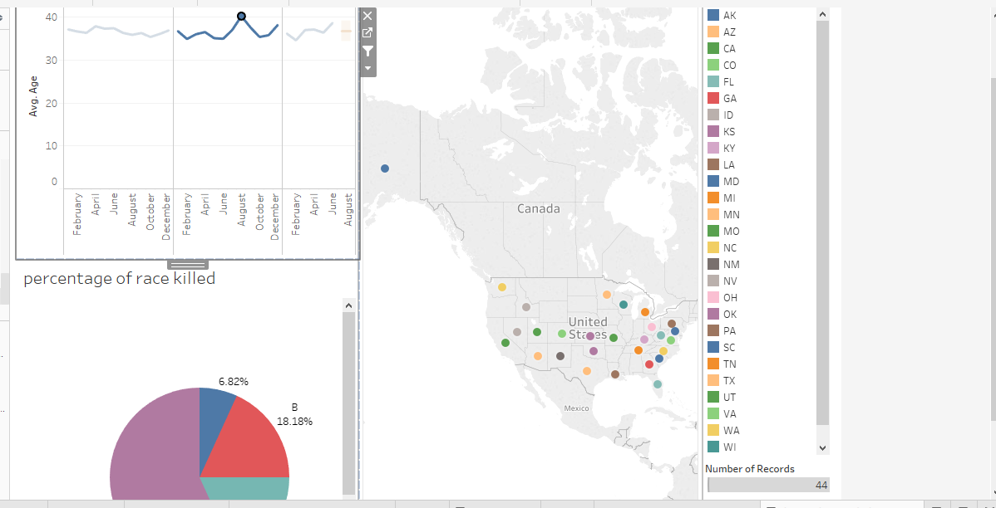

Time series dashboard showing the year and months of those killed as well as filter by states and race/ethnicity